Kyle Geddes

12/10/2023

Octave Tutorial Documentation

**Plotting**

The tutorial I followed can be found [here](https://wiki.octave.org/Using_Octave). This tutorial showed me the basics of plotting within the octave editor. The result is as shown:

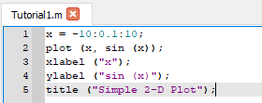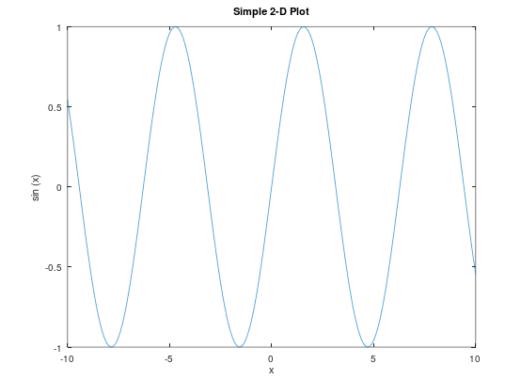

I also went though the rest of the website, and looked at anything I felt important, including:

For loops:

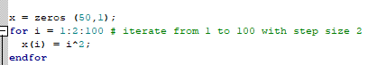

If-Statements:

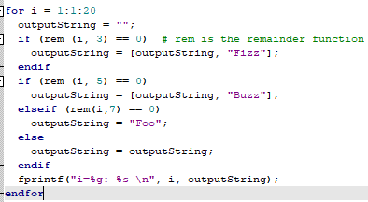

And printing, which uses the same style as C. I also examined the functions documentation, as well as random number generation.

With my new knowledge, I created:

Salter:

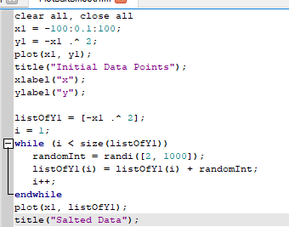

Which produced the following:

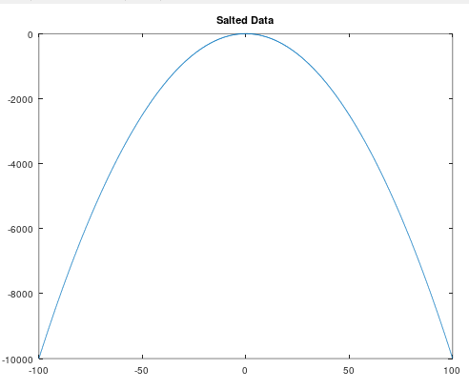

Smoothing was very challenging in Octave. In MatLab, there is a smooth() function – this does not exist in Octave yet! There was an alternative that I discovered in my frantic reading of documentations, tutorials online, and other resources. The spline() function.

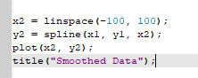

However, the only thing it did was flip the above graph over.

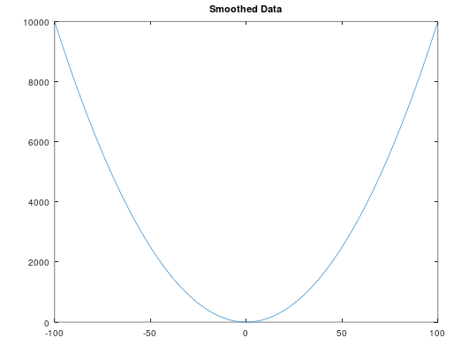

**Conclusion**

Although I am unable to successfully implement the smoother, I do believe that this experience has prepared me for the workforce when I eventually have to learn something new